20042768

Linked Open Data & IoT

UFCFLJ-15-M

Linked Open Data Project Coursework

Step 1 - Description / Evaluation

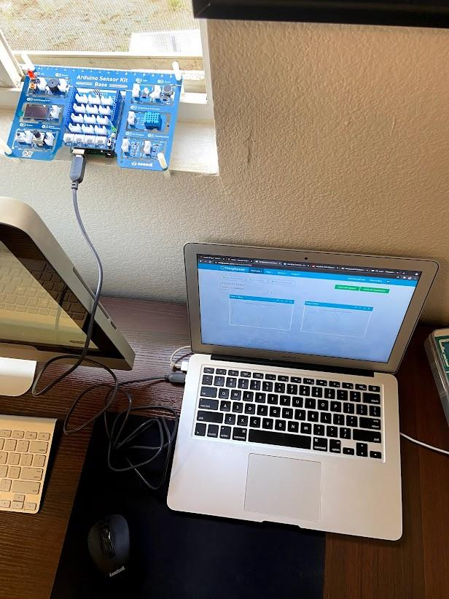

In addition to the illustration, I will provide a description of my workspace. For my physical computing project I was utilizing the Sensor Kit Base, in conjunction with the Arduino Uno R3. One of the main benefits of the base kit is that all the modules are pre-wired on the printed circuit board. Therefore that removed the need to plug into the modules individually, but rather let the PCB do the work. The initial step was to mount the Arduino Uno onto the Grove shield and then plug in the USB adapter to the Arduino and laptop. These initial steps had the hardware up and running.

In regards to smart things, one of key benefits of these units are the individual sensors. Specifically for my project I used the Temperature and Humidity sensor which utilizes a thermistor to detect and collect surrounding temperature data. The particular component that registers the humidity is composed of two plates with conductive material in the middle known as dielectric. In essence, as the sensor detects moisture, the capacity changes and relays varying voltage related to the humidity. Within the complementing code, the values were retrieved in analog format, and then converted to digital values through a built-in chip. Also in order for the code to interact smoothly, the Arduino_SensorKit library had to be imported so the sensor could output properly. All of these necessary steps resulted in the Arduino temperature sensor successfully passing values through the USB cable and onto the Arduino Create Monitor at 10 minute intervals.

Now that the hardware steps were taken care of, and the code was written to output values onto the Arduino Create Monitor, the next step was to pipe that data to the cloud, ThingSpeak. As evidenced in the Communication Lecture, the ‘Internet of Things’ is the eyes, ears, and hands of the internet. This project demonstrates the perfect example of that statement in moving data from the Arduino to the Cloud. In order to integrate this process Python code was implemented to streamline the data to ThingSpeak. The two main things that we needed in this recipe were the API write key from the ThingSpeak channel, and the Arduino port number from the online editor. With a couple of additional Python libraries imported this code did the job in a seamless fashion.

I personally went through this process twice to see the comparison of temperature and humidity from the different time intervals of day and night. At last the data was recorded, and metadata was input to cap off the project! The metadata was asked to be recorded as JSON LD. This type of RDF evolved as a spin off from JSON. To provide a brief history background, the initial way of storing information in JSON format was troublesome because there was no universal standard format. Therefore, anytime when requesting information from a webpage via a specific key the process became very ambiguous because different websites used specific keys in different ways. Essentially the JSON-LD format gives us the much needed context, provides us with identifiers, and makes it really easy to use short terminology in documents.

Step 2 - General Feelings

My thoughts before linking to ThingSpeak were to take it one step at a time. Once I was able to print outputs on the Arduino editor, it was now just a matter of configuring the Python relay successfully. During that step I did run into a bit of a bug, as I was still running the Arduino agent. The data was trying to be output to two different resources which occupied the port. Eventually I shut the Arduino agent down, and the Python relay began to work. After completing the hardware, and software portions of the project I felt like I had an exceptional understanding on the process of consuming and visualizing IoT sensor node data. As a student from MSc Data Science this is an extremely interesting process for me because one of the main coursework pieces in Data Management Fundamentals revolved around a dataset of air pollution. The same dataset that was mentioned in the very first week of Linked Open Data. Not to mention, all of that data was collected through sensors in the Bristol area. In a very convenient fashion, ThingSpeak offers users the option to export the data into a CSV for further analysis. This coursework has allowed me to come full circle in understanding the process behind collecting and processing data via the IoT.

Step 3 - Evaluation

There were many positive aspects of the experience. Near the top of these were the two platforms utilized, ThingSpeak and the Arduino Editor. The ThingSpeak platform allowed for instant visualizations streamlined to the Cloud in real time. The Arduino Editor provided a platform for putting the sensors, actuators, computation, and communication working together all in one place. Another key element which works behind the scenes of pulling information from the Web is the ontology. After going through this process of creating the necessary JSON-LD for my ThingSpeak pages I can now better understand how websites transmit data back and forth. One of the issues for me was the absolute intricate design of creating the MetaData. For example, when storing something such as properties where the page has multiple attributes that need to be input, it is easy to mess up the syntax. A way to be congruent with the intricate JSON LD design is to space everything out. Therefore it is easy for the human eye to catch an error without any IDE help. The example below demonstrates the hierarchy, and gives greater context to categorizing the different types of properties.

{

"properties" : {

"temperature" : {

"description" : "Temperature Through the Day",

"type" : "number"

},

"humidity" : {

"description" : "Humidity Through the Day",

"type" : "number"

}

}

}

Step 4 - Analysis

Hitting back on the Data Science specialization that I mentioned earlier, I believe taking Linked Open Data is a huge compliment to my resume. Not only can I better understand the process of creating and processing IoT sensor node data, but it gave me the hands-on opportunity to construct, and pipe my own data into the cloud. In addition, I have also formed a greater understanding of the ontological modeling in storing the data. The previous coursework has allowed me to view this module in a different light. Data Management Fundamentals provided me with a CSV file of over one million records to clean up, and eventually take the cleaning up file to pipe into SQL. As mentioned before, it is a great advantage to go through the entire process, and opens up many doors for similar future projects.

Moreover, the graph labeled “Temperature Through the Night” was the first graph that I constructed. Due to my location being in the United States, I wanted to translate the celsius temperatures to fahrenheit to give me better context. The very first temperature/humidity recording took place with the Arduino inside, hence why it is an outlier from the others. After the first recording I placed the Arduino on the window to get a more realistic output. Unexpectedly, ThingSpeak posted a linear relationship that allowed the temperature and humidity to increase at ten minute intervals. When I came back the next morning, one more recording was sent over which is why there is a very large time gap.

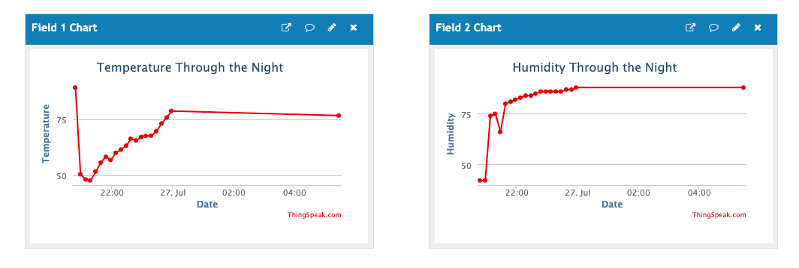

The “Temperature Through the Day” graph posted odd temperatures and humidity numbers which leads me to believe that the air flow of the A/C leaving through the window influenced the data. Subsequently, as I began the first registered temperature inside with the night graph, I did the same with the day graph. Other than the initial outlier the sensor registered in a consistent range throughout the day for temperature and humidity.

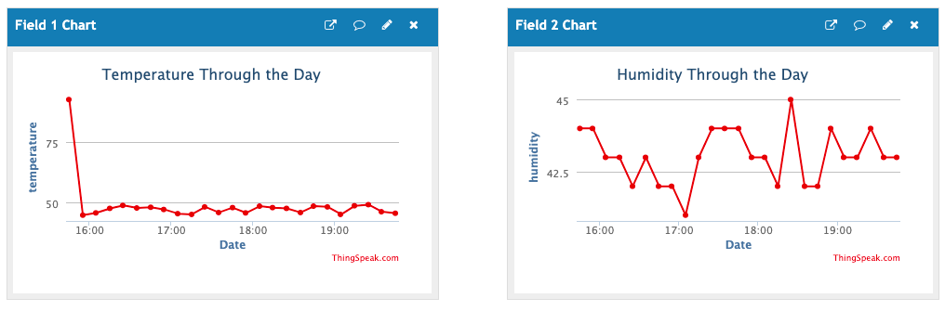

Step 5 - Conclusion / Action Plan

In summary, the skills and knowledge that I have learned from this course gives me an essential backbone understanding of Linked Open Data and the Internet of Things. In particular, this opens the door to proceed in similar experiments, and potentially join a society similar to The Maker Movement. When I am living everyday life, and walking through a city I now have a different viewpoint of all the smart things collecting data, and how they operate. From a business perspective it is interesting to see how the Titan’s of the industry continue to create their own branded Smart Things that capture an unreal amount of information that is transferred to their specific clouds on a daily basis. The question is how much data can each company gather on their users, and effectively put it to use internally or externally.

In regards to areas of knowledge or particular skills that I would like to further develop, I am determined to further research the topic of hauling data in real time via APIs. For example, the popular Pandas Python extension has a sub package known as Pandas Datareader. This is a popular software that is utilized for working with stock price datasets, something that I intend to utilize in my dissertation. The direct stream of data being transferred in real time is the epitome of the Information Age. The next time I am working with data, or walking by a smart thing in the city I am confident in my understanding of the full circle operation.

Link to ThingSpeak Channel -

Day - <https://thingspeak.com/channels/1455944/private_show>

Night - <https://thingspeak.com/channels/1457021/private_show>

Arduino Code -

<https://create.arduino.cc/editor/saammytee/405f8d07-5e4c-4273-9051-0315b82d73b3/preview>

Reference List

Futures Skills Award (2018). *Applying the Gibbs’ Reflective Model Step 2 - Feelings.* [online]. Available at: <https://www.mmu.ac.uk/media/mmuacuk/content/documents/careers/Applying-the-Gibss-Model-2018.pdf>.

Json-ld.org. (n.d.). *JSON-LD - JSON for Linking Data.* [online] Available at:

<https://json-ld.org> [Accessed 29 Jul. 2021].

Store.arduino.cc (n.d.) *Arduino Sensor Kit - Base.* [online] Available at:

<https://store.arduino.cc/usa/sensor-kit-base>